Connecting a Traditional Student Help Chatbot to Azure AI Language Service
Student Name
University of the Cumberlands
Course
Instructor
Date

Connecting a Traditional Student Help Chatbot to Azure AI Language Service
Introduction
AI has revolutionized human interaction with the computer system. The chatbot is considered one of the most widespread use cases of artificial intelligence, which enables users to address software in natural language rather than the standard menus or instructions. Although rule-based chatbots can help to answer repeated questions, they are restricted as they can respond to a set of preset commands. Artificial intelligence services based on cloud computing circumvent this issue by enabling chatbots to examine language, interpret user purpose and comprehend sentiments conveyed via text.
This project was aimed at creating a classical Student Help Chatbot and uniting it with Microsoft Azure AI Language Service. The chatbot was developed with Python in Visual Studio Code and integrated with Azure AI Sentiment Analysis by use of the Azure SDK. The last one is a mix of rule-based answers with artificial intelligence that enables it to offer preset replies as well as to analyze the tone of user messages. This project has shown that cloud AI services can be used to augment functionality of a standard chatbot without necessarily having the developer develop intricate machine learning models anew.
Chatbot Development Lifecycle
The chatbot has been modeled after an organized software development lifecycle that comprises of planning, design, implementation, testing, installation, and assessment. The planning phase entailed what the chatbot would be used to do. Chatbot programmed to respond to typical university questions also included additional intelligence Azure AI sentiment analysis. Common questions were the greetings, office hours, library query, tuition information, and contact information of the university. A conversation flow based on a rule set was designed during the design phase. The chatbot analyzes the user input through predetermined keywords using Python conditional statements. In case the user types something that the chatbot recognizes, it presents the respective response instantly. In case the message lacks a predefined command, it is sent to the Azure AI Language Service to be sentimental.
The implementation in Visual Studio Code was done by using Python. Azure AI Text Analytics SDK was deployed, and a resource, namely an Azure Language Service, was created using the Azure portal. The access key and the API endpoint were accessed in the Azure Keys and Endpoint page, and inserted into the Python application to verify the requests. Development testing was done continually. All the preset commands were tested separately, and various sentences were tested to be sure that the Azure correctly interpreted positive, neutral, and negative sentiments. Once it had been tested successfully, the source code was pushed on GitHub to meet the project submission requirements.
Development of the Student Help Chatbot
The chatbot was coded in all Python with a straightforward rule-based design. A loop will be used to ensure that the chatbot stays online until the user codes "bye" to the bot. The chat has a chatbot that converts all entries of the user to lower case then proceeds to match the input to increase matching accuracy.
Some of the pre-determined answers were introduced such as:
- Hello
- Help
- Office Hours
- Library
- Fees
- Contact
- Bye
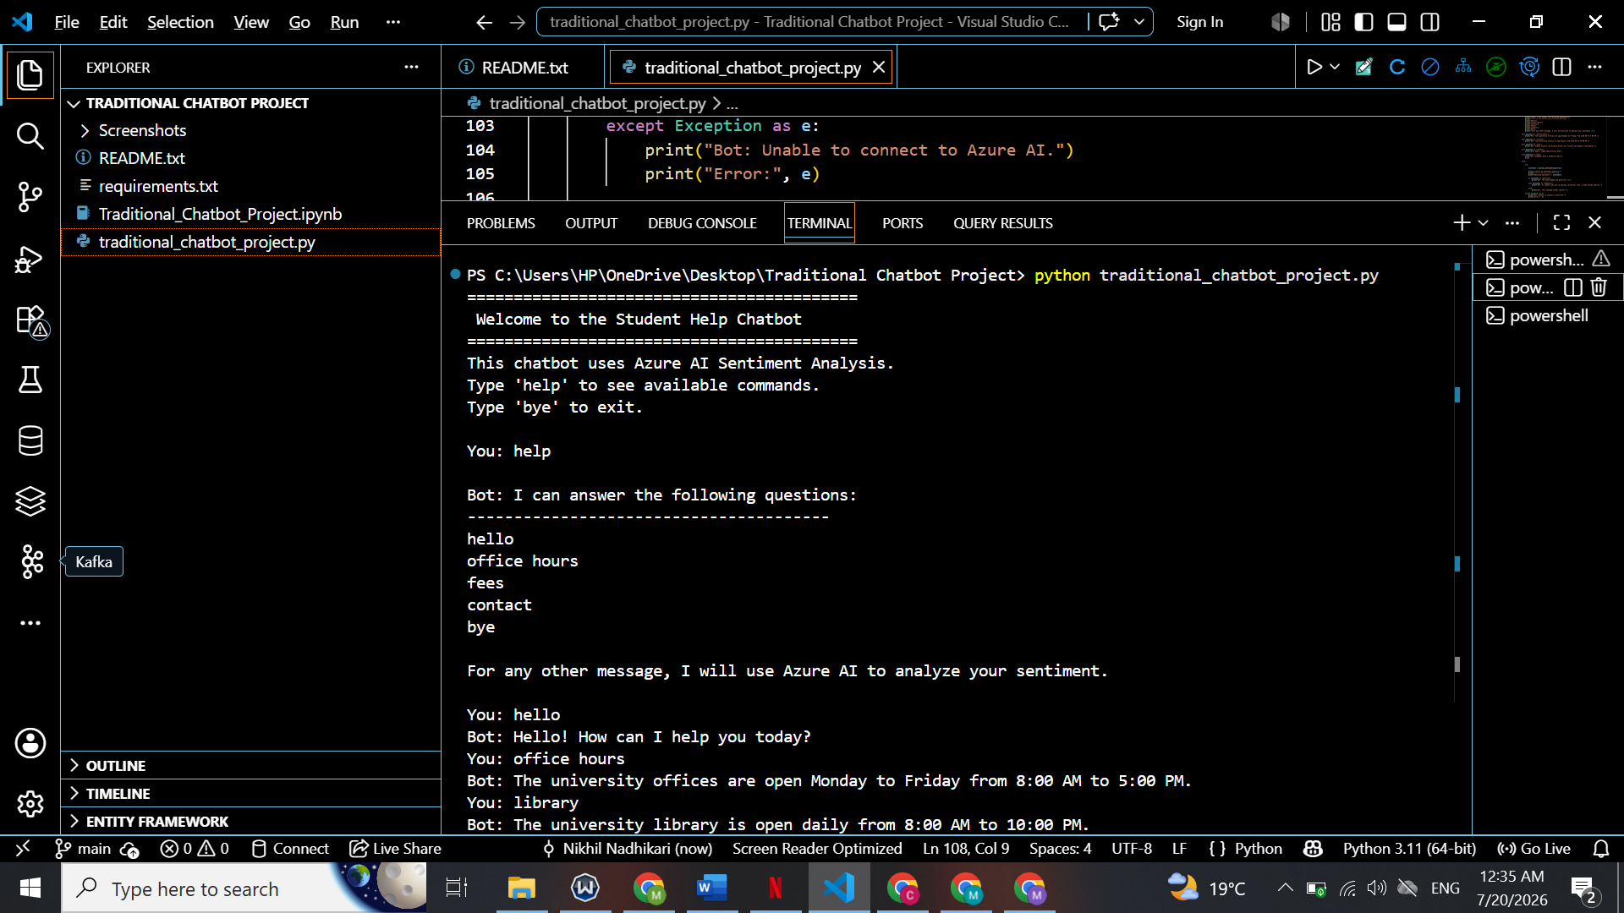
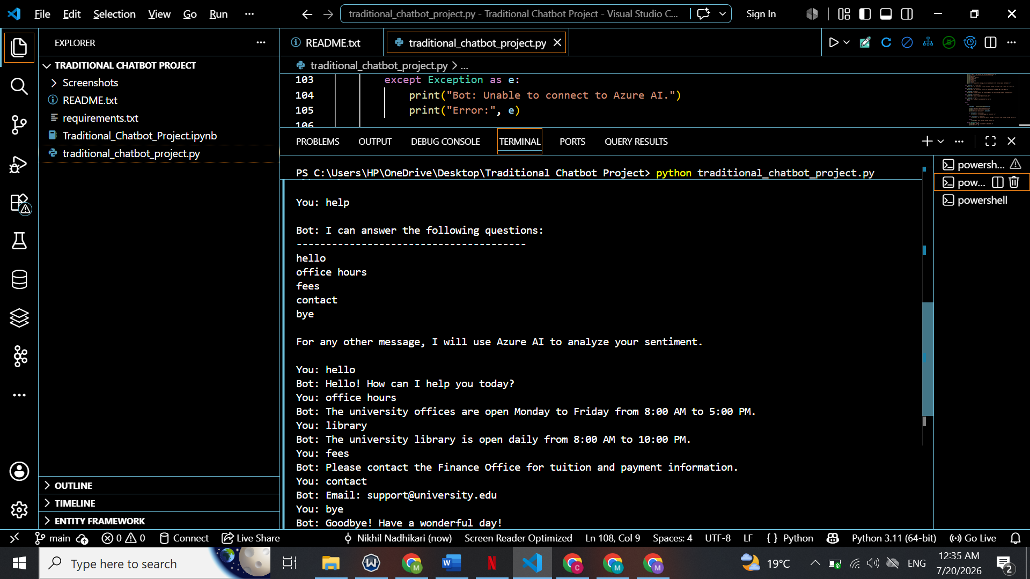
The help command will list the capabilities of the chatbot so its users can know what commands this chatbot will support. Upon the user typing a question to which the chatbot is unfamiliar, the chatbot is not presented with an error message as before. The message is rather sent to the Azure AI to have the sentiment analyzed, then the user is made aware that there is no predefined message. This would provide users with a more interactive and intelligent user experience compared to a rules-based chatbot. The chatbot was simple and easy to maintain, as Python had conditional statements that were easy to comprehend and edit. New commands can simply be added into the program by adding new conditions.
Integrating Azure AI Language Service
The biggest addition to the chatbot was the incorporation of Microsoft Azure AI Language Service. Azure also offers a cloud Text analytics API that can tell which sentiment is conveyed in text without developers needing to create or train machine learning features. An Azure for Students subscription was used to create a Language Service resource. At first, deployment did not work as the East US region had limited deployment due to the student subscription policy. Following the test of the deployment error, there was a successful recreation of the resource in Central US region. After a successful deployment, the Keys and Endpoint page was used to get the endpoint URL and the authentication keys to be used to connect Python to Azure AI. In the Python app, it imported the libraries of the Azure SDK and instantiated the TextAnalyticsClient object with the help of the endpoint and the AzureKeyCredential. Each time a user types in an unfamiliar sentence, the chatbot forwards the sentence to Azure.
Azure breaks the text down and gives one of three types of sentiment:
- Positive
- Neutral
- Negative
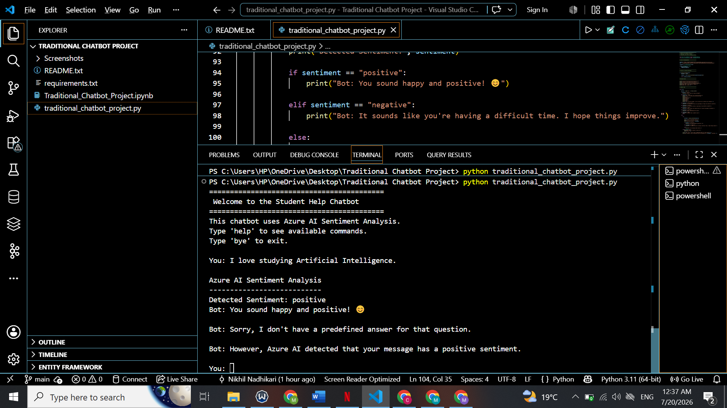
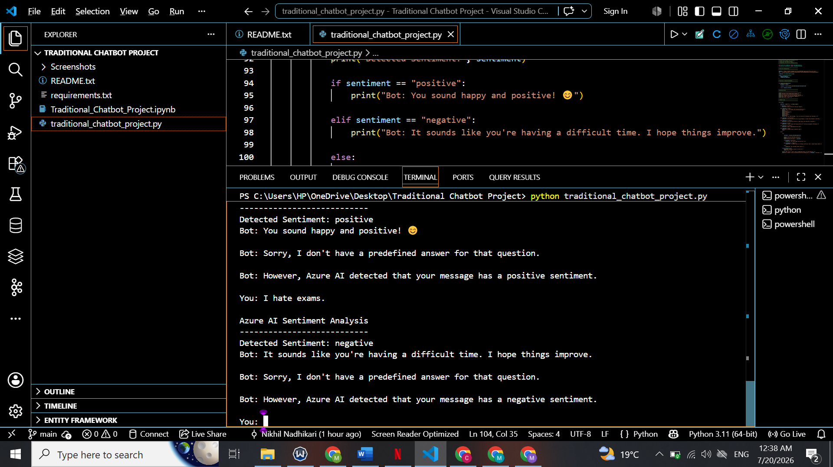
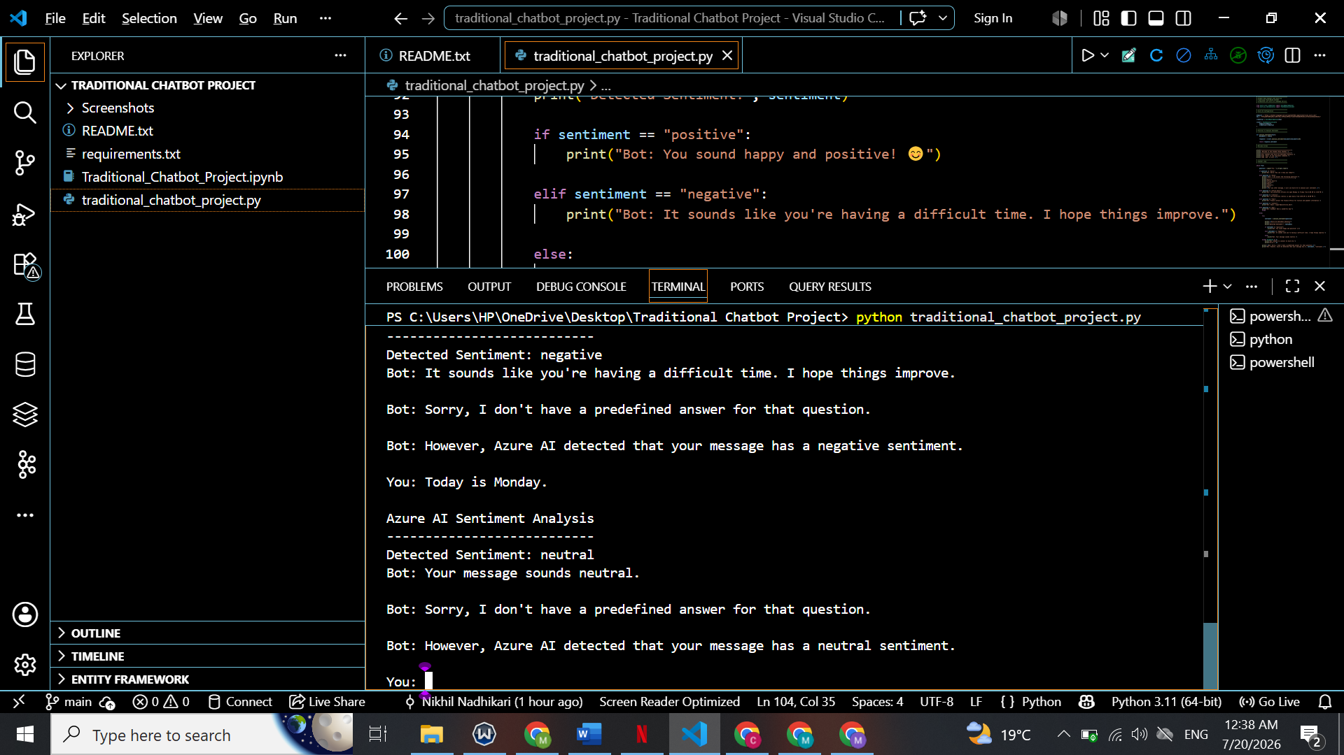
The chatbot gives a positive response, based on the feeling sent back. As an illustration, when Azure recognizes a positive sentiment, the chatbot alerts the user that he or she sounds happy and positive. In case of a negative sentiment that is identified by Azure, the chatbot will answer with a sympathetic message that recognizes the possibility of the user being frustrated.
The integration showed that cloud AI services can enhance the abilities of traditional software significantly and need only a bit more coding.
Testing and Results
During development, testing was done to ensure the standard functionality of the chatbot as well as integration with Azure AI. The predefined commands have been initially tested. The chatbot was able to respond appropriately to questions about office hours, library services, tuition fees, contact information, greetings, and help commands. The exit command was able to close the program. Additional testing of sentiment-analysis of Azure. Following the input of the sentence I love studying Artificial Intelligence, an appropriate response was provided through the correct classification of the sentiment and was positive. Correct classifications were also achieved in similar tests involving neutral and negative sentences. The completed project revealed that the chatbot was able to develop a combination of deterministic rule-based logic with cloud-based artificial intelligence. Users had automatic responses to simple queries around the university as well as the advantage of sentiment analysis by artificial intelligence to more broad discussions. The eventual system had met all of the main project goals of combining Python and Microsoft Azure AI Language Service and effectively, had the ability to conduct sentiment analysis using cloud APIs.
Challenges Encountered and Mitigation Strategies
There were a number of development challenges. Accessing Azure resources was the initial challenge. The deployment of the Language Service, at first, had failed since the site of East US was not allowed under the policy of Azure for Students subscription. The deployment region was updated to Central US, after reading the error message of the deployment, which led to a successful creation of the resource.The other difficulty was the choice of a single name of an Azure resource, asAzure service names must be globally unique. A solution to this dilemma was to append an identifying name to the resource name.
Attentive installation was also needed in the installation of the Azure SDK. Firstly, the Python program did not run properly due to missing packages. The dependency issues were resolved by installing the needed libraries with pip. Another problem came about when sentiment analysis was incorporated. The chatbot also showed the Blue sentiment response as well as the 'standard' Sorry I do not understand message. This was the case because the program did not quit upon showing the AI result. The problem was solved through the adjustment of the chatbot logic as the sentiment analysis will be the chatbot response to unknown inputs rather than invoke the default message. These problem-solving exercises enhanced the knowledge on how to deploy Azure, manage Python packages, do cloud authentication, and debug programs.
Lessons Learned
The work on this project was the great experience in the field of cloud computing, artificial intelligence, and software development. Among the lessons that were learned was the distinction between a typical rule-based chatbot and an AI-enhanced chatbot. Rule-driven systems can be efficient and predictable on known questions and are not able to interpret new user input. Cloud AI-driven services address this shortcoming by dynamically analyzing the language. The other lesson was to understand how APIs can be used to communicate between local applications and cloud services. Developers can make secure requests to Azure and get smart responses in a couple of seconds, as opposed to local execution of complex machine learning algorithms.
Incremental development, debugging, and testing were also emphasized in the project. Minor issues with implementations (wrong Azure regions or schells not included) did not allow successful execution until it was investigated and resolved. Lastly, GitHub also offered a good source code management platform, version-control and documentation of project. GitHub combines the benefits of code security, a means of easy sharing, and the ability to make enhancements later in the future.
https://github.com/SP-create7/Traditional-Chatbot-Azure-AI
Conclusion
This project has been able to illustrate how an old fashioned Python chatbot and Microsoft Azure AI Language Service can be integrated. The chatbot responded to pre drafted questions related to the university although it used the Azure AI to analyze the sentiment of the user message in general. The integration of rule-based reasoning with the cloud-based artificial intelligence provided a stronger and more interactive application of either of the two approaches.
Though the chatbot is fairly basic, it provides a solid base to make it more generic in the future, like natural language understanding, speech recognition, multilingual support, integration with a database, and generative AI features. In general, this project was a great experience in Python, Azure cloud computing, and API integration, version control in GitHub and testing of software and demonstrated how cloud AI services can be used to enhance traditional applications.
AI Usage Disclosure
This project utilized artificial intelligence to help explain code, debug, organize reports, use improved grammar, and APA format. The student performed all the chatbot development, set-up of the Azure resources, testing, integration to GitHub, validation of outputs, and final review to make sure that the work is reflective of the implemented project.

References
Microsoft. (2025). Azure AI Language documentation. https://learn.microsoft.com/azure/ai-services/language-service/
Microsoft. (2025). Azure AI Text Analytics client library for Python. https://learn.microsoft.com/python/api/overview/azure/ai-textanalytics-readme
GitHub. (2025). GitHub documentation. https://docs.github.com/en
Python Software Foundation. (2025). Python documentation. https://docs.python.org/3/
University of the Cumberlands. (2026). Connecting a chatbot to an AI-as-a-Service project instructions.

